PureFlow AI: IoT-based Predictive Maintenance System for Water Refilling Stations using XGBoost and Autoencoder Algorithms

A Thesis/Project Study/Capstone Design Study
Prepared and Presented to the
Computer Engineering Department
Colegio de Muntinlupa

In Partial Fulfilment of the Requirements for the Degree of
Bachelor of Science in Computer Engineering

by

Abosejo, Mandy Mae F.
20231020258

Borras, Carl Renzo D.
20231020250

Mustar, Gian Lloyd T.
20231020412

Engr. Ricrey E. Marquez
Adviser

APPROVAL SHEET
This design project hereto entitled:

“PureFlow AI: IoT-based Predictive Maintenance System for Water Refilling Stations using XGBoost and Autoencoder Algorithms”

prepared and submitted by MANDY MAE F. ABOSEJO, CARL RENZO D. BORRAS, GIAN LLOYD T. MUSTAR, in partial fulfillment of the requirements for the degree Bachelor of Science in Computer Engineering, has been examined and is recommended for acceptance and approval for FINAL DEFENSE.

Engr. Ricrey E. Marquez
Adviser

Approved by the Committee on Oral Examination with a grade of ______ on MAY 2, 2026.

Dr. Cyd Laurence Santos
Chair

Engr. Tristan Jay Calaguas Engr. Evelyn De Castro
Member Member

Accepted in partial fulfillment for the degree of Bachelor of Science in Computer Engineering.

DR. JOHN MARK PAYAWAL
OIC, Vice President for Academic Affairs

Dr. Teresita C. Fortuna, CESO III
- College President

Acknowledgement
- First and foremost, we would like to express our profound gratitude to our research and course adviser, Engr. Ricrey E. Marquez. We are deeply indebted to him for his tireless guidance, technical expertise. As our course adviser, he provided the academic foundation necessary for this work. His patience and belief in our project were the driving forces that kept us moving forward through every technical hurdle.
- We also wish to extend our sincere appreciation to the members of the defense panel: Dr. Cyd Laurence Santos, Engr. Tristan Jay Calaguas, and Engr. Evelyn De Castro. We are grateful for the time and effort they dedicated to reviewing our work. Their insights, questions, and constructive criticism during the defense were instrumental in refining our findings and ensuring the integrity of this paper. Their expertise has significantly broadened our understanding of this field.
- Our deepest thanks go to our families. We are forever grateful for their unconditional love, unwavering support, and the financial sacrifices they made to provide us with the opportunity to pursue our education. Their constant encouragement and patience during our long hours of study and late-night sessions served as our source of strength in this endeavor.
Finally, we would also like to acknowledge our friends and colleagues, especially our important colleagues, Cedrick Allapitan and Julliana Leonore Boragay for their camaraderie and support. We are grateful to those who offered a listening ear, shared their technical insights, or simply provided a morale boost during the most stressful phases of this project.

Abstract
Water refilling stations play a vital role in providing safe drinking water to the community, yet many face challenges due to unplanned maintenance, equipment failure, and inconsistent water quality, which often leads to wasteful resource consumption, increased operational cost, and reduced system efficiency. To address these issues, this study focuses on developing the PureFlow AI which is an IoT-based Predictive Maintenance System for Water Filtration Systems in Water Refilling Stations using XGBoost and Autoencoder Algorithms. The system is designed to enable data-driven maintenance scheduling and early fault detection by monitoring key components. It employs sensors to gather real-time data and equipment operational status. An ESP32 microcontroller manages data collection and control mechanisms. Anomaly Detection is integrated to identify unusual patterns or deviations in operational parameters indicative of impending failure. An ESP32 collects different sensor data and uploads it in a dashboard for processing. This platform hosts the ML algorithms responsible for water potability and forecasting of filter degradation and estimating Remaining Useful Life (RUL). By integrating these predictive techniques, the system aims to proactively predict maintenance needs, reduce operational downtime, and enhance efficiency by providing outputs such as remaining lifespan.

Keywords: Anomaly Detection, Internet of Things, Predictive Maintenance, Water Refilling Station, XGBoost

Table of Contents

Approval Sheet 2
Acknowledgement 3
Abstract 4
Table of Contents 5
List of Tables 6
List of Figures 7
Introduction 8
Methodology 28
References 47

List of Tables
Table 1. Cost Analysis 34
Table 2.Model Identification 35
Table 3. Structured KPI Table 35
Table 4. Dataset Identification 36
Table 5. Model Training Result 37
Table 6. XGBoost RUL Decision Table 38
Table 7. Predictive Maintenance Decision Flow Table 41
Table 8. Physical System 45
Table 9. Respondent Profiles 46
Table 10. Water Quality Validation Parameters Based on PNSDW 2017 49

List of Figures
Figure 1. Input Process Output Diagram 28
Figure 2. Methodological Framework of the Study 31
Figure 3. System Overview 32
Figure 4. Predictive Maintenance and Water Filtration System Logic 33
Figure 5. Confusion Matrix of Water Potability Model 38
Figure 6. Scatter Plot of Actual vs. Predicted RUL Model 39
Figure 7. PureFlow AI Dashboard - Sensor Monitor 39
Figure 8. PureFlow AI Dashboard - Alerts & Notifications 40 Figure 9. PureFlow AI Dashboard - Maintenance Schedule 40
Figure 10. Front view of PureFlow AI 3D Model 43
Figure 11. Rear view of PureFlow AI 3D Model 44
Figure 12. Top view of PureFlow AI 3D Model 44
Figure 13. Side view of PureFlow AI 3D Model 45
Figure 14. Tentative Gantt Chart 59

Introduction
Without a plan, maintenance becomes reactive, meaning you only fix things when they break. This leads to unpredictable downtime, expensive emergency repairs, lower asset lifespan and potential safety violations. Over time, it erodes productivity and profitability. (FieldEx Team, 2025). The maintenance of the systems has recently become increasingly important for enhancing product efficiency and continuity. Different varieties of system maintenance exist, such as reactive, planned, proactive, and predictive. (Ucar et al. ,2024). A traditional approach to maintenance is reactive maintenance, where equipment is repaired or replaced only after a breakdown occurs. While simple and cost-effective in the short term, this method often leads to unplanned downtime, expensive repairs. Another common practice is planned or preventive maintenance, in which regular inspections, cleanings are scheduled at fixed intervals regardless of the actual condition of the system. Although this helps reduce unexpected failures, it can result in unnecessary part replacements and wasted resources. Some stations also practice proactive maintenance, which focuses on identifying and addressing the root causes of degradation through manual monitoring of parameters. However, this approach still depends heavily on operator expertise and visual inspection, making it prone to human error.
In recent years, the concept of predictive maintenance has emerged as an advanced solution, utilizing Internet of Things (IoT) sensors and data analytics to monitor equipment health and predict potential failures. By analyzing real-time data from various sensors, this approach enables early detection of issues and allows maintenance to be performed only when necessary. As a result, predictive maintenance minimizes downtime, reduces operational costs, extends equipment lifespan, and ensures consistent water quality compared to traditional maintenance methods.
This study also supports the United Nation’s Sustainable Development Goals (SDGs). Such as SDG 6 - Clean Water and Sanitation, it Ensures Availability and Sustainability Management of Water and Sanitation for all. SDG 9 - Industry, Innovation and Infrastructure, Build resilient Infrastructure, promote Inclusive and Sustainable Industrialization and Foster Innovation.
This study proposes an innovative IoT-based Predictive Maintenance System that directly addresses the challenges of equipment failure, resource waste, and inconsistent water quality currently facing local water refilling stations. The ultimate goal is to enhance operational efficiency, ensure system scalability, and provide quantifiable output such as remaining useful life to reduce downtime and operational costs, thereby supporting both local industry resilience (SDG 9) and the consistent delivery of clean water (SDG 6).
Despite the growing body of research on predictive maintenance and IoT-based water quality monitoring, existing systems have largely been designed for large-scale industrial facilities with stable data pipelines, dedicated IT support, and substantial budgets. Small-scale, commercial water refilling stations — the primary affordable drinking water source for millions of low-income households in the Philippines — operate under different constraints: limited maintenance budgets, variable operator expertise, smaller and noisier sensor datasets, and informal maintenance culture that resists schedule-based interventions. Limited work has been proposed as an integrated, edge-deployable hybrid AI system tailored specifically to these operational realities. PureFlow AI is positioned as a system to directly address this gap, offering a cost-effective, localized predictive maintenance solution validated against the actual conditions of Philippine water refilling stations.

Background of the Study
Based on the blog post from UpKeep (2024). Unplanned maintenance is a maintenance task that must occur when an unexpected breakdown of an asset occurs. If there is no formal strategy to address a repair, replacement, or inspection before it’s needed, the unanticipated equipment failure is categorized as ‘unplanned maintenance.’ You might also hear unplanned maintenance referred to as “reactive” or “emergency” maintenance because the maintenance team is forced to figure out the issue immediately. Whether from equipment breakdowns or human error, unplanned maintenance can ultimately lead to lost time and money. While it’s impossible to prevent all downtime from unplanned maintenance, the key to ensuring it doesn’t spiral out of control is managing the unplanned maintenance before it happens. In other words, expect the unexpected. A major effect of unplanned maintenance is increased costs for equipment repair or replacement (including parts), labor, and overtime of maintenance workers. But the negative effects don’t stop there. Unplanned maintenance can also lead to: Lost production, Damaged equipment, Reduced asset life, Disrupted planned maintenance, Strained supply chain, Decreased employee morale, Safety concerns.
Different varieties of system maintenance exist, such as reactive, planned, proactive, and predictive. Reactive maintenance only solves the issue when the system breaks down or malfunctions. The malfunction becomes apparent, and then the repairing steps are applied. Planned maintenance is previously scheduled to perform regular inspections and maintenance tasks at predetermined intervals to prolong the system’s life and reduce repair costs, regardless of whether the system has shown failure signs. Predictive maintenance (PdM) is an approach applying advanced analytics on the obtained data from multiple sensors to predict when the system tends to fail and organize the maintenance tasks accordingly to optimize maintenance intervals, reduce malfunction time, and enhance the system’s reliability. (Ucar et al. ,2024).
The Philippines’ water availability and quality are alarming. 43% of the country’s rivers and 56% of the country’s major water bodies are polluted. While 91% of households have access to basic water services, access is unequal, with some regions having access as low as 62%. Furthermore, 52% of households lack access to a safely managed water supply. Polluted drinking water led to an average of around 50,000 cases of waterborne diseases annually between 2010 and 2019. (Koons, 2024). Safe drinking water and proper sanitation facilities are essential to health and wellness. Safe water and sanitation is especially linked to young children’s nutrition and ability to stay healthy and focused in school. Diseases caused by unsafe or unhygienic practices decrease children’s chances to successful school completion and healthy growth. In rural areas where poverty is high, inequalities are aggravated by this cycle of and link between the lack of access to safe drinking water and sanitation, and poor health and low productivity. (Jern, 2021). which shows the importance of water stations.
To validate the need for an advanced maintenance solution, a preliminary assessment was conducted at a target water refilling station. The findings confirm that reliance on traditional and subjective maintenance scheduling leads to significant operational and financial liabilities. The primary sources of unscheduled maintenance were identified as the High-Pressure Reverse Osmosis (RO) Pump and the Sediment Filter Housing. Component failure results in substantial operational downtime, typically ranging from 4 to 8 hours for minor issues. More critically, major failures, such as pump or RO membrane-related issues, can halt operations for 1 to 2 days. These unexpected breakdowns incur high financial costs, with pump failures alone costing between ₱6,000 to ₱15,000 for labor and replacement parts. The current maintenance decisions are often reactive, based on subjective indicators like visible dirt, drop in flow rate, or change in water taste. This lack of data-driven scheduling results in inefficiencies: sediment filters are sometimes replaced prematurely (e.g., every 2–3 weeks) due to high turbidity, leading to resource waste. Conversely, essential components like carbon filters are sometimes replaced too late, resulting in noticeable chlorine breakthrough and compromising water potability.
In recent years, predictive maintenance has gained attention as a modern, data-driven approach that integrates Internet of Things (IoT) technology with real-time monitoring and intelligent analysis. Predictive maintenance (PdM) uses data analysis to identify operational anomalies and potential equipment defects, enabling timely repairs before failures occur. It aims to minimize maintenance frequency, avoiding unplanned outages and unnecessary preventive maintenance costs. (Goncalves, 2022).
This study is grounded in the urgent need to shift water refilling stations from inefficient reactive or schedule-based maintenance toward a more intelligent, data-driven predictive maintenance framework. Despite the growing adoption of IoT and machine learning in industrial maintenance, local water refilling stations in the Philippines still rely heavily on subjective indicators and fixed maintenance schedules, which often lead to premature filter replacement, delayed intervention, costly equipment breakdowns, operational downtime, and compromised water quality. Given the critical role of water refilling stations in ensuring public access to safe drinking water, particularly in areas where water quality remains a national concern, there is a strong rationale for developing a system that can proactively monitor filtration performance, and predict equipment degradation.
A research gap exists in the limited availability of cost-effective, localized predictive maintenance systems specifically designed for small-to-medium-scale water refilling stations. While previous studies have explored IoT-based water quality monitoring, predictive maintenance, or individual machine learning models such as XGBoost, and Autoencoders, few have integrated these technologies into a single hybrid framework tailored to the operational realities of Philippine water refilling stations. Moreover, existing systems often focus only on water quality assessment or cloud-dependent monitoring, with limited emphasis on real-time edge-based anomaly detection, Remaining Useful Life (RUL). This study addresses these gaps by proposing an IoT-based predictive maintenance system that combines XGBoost for water potability and filter degradation, and Autoencoder for anomaly detection to deliver a comprehensive, scalable, and economically viable solution. By bridging this technological and contextual gap, the research seeks to enhance operational efficiency, reduce downtime, lower maintenance costs, and ensure more consistent delivery of safe drinking water.
The development and evaluation of the system will follow the CRISP-DM framework and will later be validated through black-box functional testing using predictive maintenance Key Performance Indicators (KPIs).
Statement of the Problem
Water refilling stations play an important role in providing safe and accessible drinking water to communities. However, Traditional maintenance practices often rely on manual inspection or fixed maintenance intervals, which can lead to unexpected breakdowns, reduced water quality, increased time consumption, and increased operational costs.
The study aims to address the inefficiency, high operational costs, and downtime experienced by water refilling stations due to reliance on subjective or time-based maintenance scheduling, which often results in premature component replacement or unexpected equipment failure.
- How can an IoT-enabled sensing and data acquisition framework be designed and implemented to accurately collect, validate, and preprocess operational and water-quality parameters such as flow rate, pressure, turbidity, TDS, pH, and temperature as reliable inputs for predictive maintenance models?
- How can machine learning models, specifically XGBoost, and Autoencoder be designed and integrated to classify Water Potability, Remaining Useful Life (RUL) prediction, and anomaly detection in order to assess filtration system health and identify potential failures at an early stage?
- How effective is the predictive maintenance system in monitoring and assessing the health and functional condition of water filters, particularly in estimating remaining useful life (RUL), and ensuring the delivery of potable water within acceptable quality standards at water refilling stations?
Objectives of the Study
To design, develop, and evaluate PureFlow AI: IoT-based Predictive Maintenance System for Water Refilling Stations using XGBoost and Autoencoder Algorithms to ensure optimal component lifespan, reduce downtime, and enhance operational efficiency.
- To design and implement an IoT-enabled sensing and data acquisition framework that collects, validates, and preprocesses operational and water-quality parameters from water filtration systems as reliable inputs for predictive maintenance models. all collected parameters validated against the thresholds defined by the Philippine National Standards for Drinking Water (PNSDW) 2017.
- To design and integrate machine learning models (XGBoost, and Autoencoder) for Water Potability, Remaining Useful Life (RUL) prediction, and anomaly detection to assess filtration system health and identify potential failures early.
- To evaluate the effectiveness of the developed predictive maintenance system in monitoring and assessing the health and functional condition of water filters, particularly in estimating remaining useful life (RUL), and ensuring the continuous delivery of potable water.
Significance of the Study
The proposed PureFlow AI: IoT-based Predictive Maintenance System for Water Refilling Stations using XGBoost and Autoencoder Algorithms aims to provide aid to the following benefactors:
Households and Individual Consumers, the study provides a safe and clean access to drinking water by having a continuous reliable source of drinking water.
Water Service Provider, the study allows for planned, efficient predictive maintenance schedules rather than reactive emergency system breakdowns.
Environmental Sector, the study contributes to environmental sustainability by minimizing waste through optimized filter usage based on actual need rather than a fixed schedule.
Researchers, the conduct of this study allows the researchers to enhance their technical skills and research competencies. Through the development and implementation of the system, they gain practical experience in integrating IoT with AI technologies such as XGBoost algorithms and Autoencoder for Anomaly Detection.
Future Researchers, the study contributes to the advancement of predictive maintenance. It offers insights into how emerging technologies can be applied to real-world problems, opening opportunities for future research and innovation in other IoT systems.

Literature Review
Anomaly Detection
Despite the success of these predictive models, a major limitation in existing IoT implementations is the latency associated with cloud-based processing, which hinders "Real-Time" Anomaly Detection. Rhachi et al. (2025) argue that many systems described as "real-time" actually rely on batch processing—sending data to a cloud server for analysis—which introduces delays that can be catastrophic for fast-acting mechanical faults like pump cavitation or water hammer. To address this, a recent scholarship focuses on Edge Computing and unsupervised learning techniques. Baranwal et al. (2025) demonstrated that lightweight Autoencoder neural networks can be deployed on edge devices to detect anomalies. By training the Autoencoder exclusively on "healthy" data, it learns to reconstruct normal patterns; any significant deviation in the reconstruction error signals an immediate anomaly. This allows for instant fault detection at the device level, independent of internet connectivity.
Internet of Things
Kushwaha & Pandey (2025) explain that IoT enables real-time water monitoring using sensors (pH, turbidity, temperature, TDS) connected to low-cost microcontrollers like ESP32 and NodeMCU. Data is transmitted to the cloud for remote access and analysis, overcoming the limits of manual methods. Ansari & Vidyarthi (2025) claim that IoT improves productivity, safety, and downtime at water refilling stations by enabling real-time monitoring, automation, and data-driven insights. It gathers data and sends it to the cloud for analysis using sensors, microcontrollers, and communication protocols. Combined with algorithms like XGBoost and autoencoders, IoT systems can predict issues and detect anomalies, allowing proactive maintenance and improved efficiency in applications like PureFlow AI.
Predictive Maintenance
The concept of predictive maintenance has evolved with the integration of artificial intelligence and IoT technologies. Velasco-Loera et al. (2025) emphasized the interpretability of predictive maintenance models, suggesting that hybrid frameworks improve the explainability and trustworthiness of predictions. Cummins et al. (2024) conducted a comprehensive review of explainable predictive maintenance techniques, identifying challenges in balancing model transparency and predictive power. In a similar vein, Davari et. al. (2021) showcased the cost reduction and efficiency benefits of predictive analytics in railway maintenance. Kim and Choi (2021) These findings collectively indicate that predictive maintenance not only enhances operational reliability but also supports sustainability and efficiency in industrial operations. This efficiency extends to sensor optimization; for example, while monitoring residual chlorine is necessary to prevent oxidative damage to Thin-Film Composite (TFC) RO membranes, continuous online chlorine sensing presents significant hardware and economic limitations for small-scale IoT deployments. Research by Dada et al. (2024) and Guezouli (2024) indicates that optical and amperometric chlorine sensors suffer from rapid calibration drift and high maintenance costs. Instead, predictive maintenance frameworks utilize proxy physical parameters—specifically feed pressure drops and influent turbidity—to infer pre-filter clogging and carbon block saturation, thereby preserving system cost-effectiveness and operational autonomy.
Water Refilling Stations
Recent research has extended predictive modeling into the domain of water refilling and quality management. Nie et al. (2022) developed a hybrid ARIMA–LSTM model for predicting the Remaining Useful Life (RUL) of hydraulic valves in water systems, achieving a prediction error below 1.6%, which validated its applicability in real-world water systems. Similarly, Sarker et al. (2025) benchmarked six machine learning models on groundwater quality prediction using parameters including TDS and turbidity, and found that XGBoost outperformed all others with an R² of 0.97, RMSE of 1.72, and MAE of 1.38, confirming its superiority in capturing nonlinear relationships among the same water quality variables measured by PureFlow AI's IoT sensor array. In selecting these parameters, minimizing multicollinearity is critical for model optimization. According to Demetillo et al. (2019) and Pasika & Gandla (2020), online TDS sensors utilize electrical conductivity measurements to estimate dissolved ion concentrations, rendering standalone electrical conductivity (EC) sensors redundant in low-cost IoT node designs. By leveraging a single TDS sensor post-Reverse Osmosis (RO) stage, the system efficiently captures membrane degradation and solute breakthrough required for forecasting without introducing feature redundancy. Shofiana et al. (2025), Naim et al. (2025), and Gill et al. (2023) all reinforced the potential of machine learning models like XGBoost in accurately classifying water quality, proving essential for automated quality assurance in refilling stations. These studies suggest that hybrid models and predictive algorithms are crucial in improving operational efficiency and sustainability within water-based industries.
XGBoost
Extreme Gradient Boosting (XGBoost) has emerged in the literature as a robust algorithm for categorizing specific operational states (e.g., differentiating between a "clogged filter" and a "pump failure"). Toleva et al. (2023) conducted a comparative analysis of machine learning models for water quality classification and found that XGBoost consistently outperformed other classifiers like Random Forest and Support Vector Machines (SVM) in terms of speed and accuracy. Its ability to handle non-linear feature interactions and provide "feature importance" scores makes it particularly valuable for industrial diagnostics, where understanding which sensor triggered an alarm is as important as the alarm itself. Koli et al. (2025) compared the performance of Support Vector Machine (SVM) and XGBoost in water quality analysis and found that XGBoost consistently achieved superior robustness and a 90% accuracy rate. Likewise, Salim et. al. (2022) optimized XGBoost using a Genetic Algorithm (GA-XGBoost), which produced higher accuracy and reliability in classifying water pump system conditions. Lastly, Sharma et al. (2024) demonstrated the efficiency of gradient boosting classifiers such as XGBoost for water purity analysis, while Gill et al. (2023) validated XGBoost’s superiority in assessing groundwater quality through classification-based prediction of Water Quality Index (WQI). Extending XGBoost beyond classification, Saddiqi et al. (2024) applied the algorithm to predict membrane degradation in water treatment systems, achieving R² values of 0.97 for transmembrane pressure and 0.95 for total resistance — demonstrating XGBoost's capability to model continuous degradation indicators, a property directly applicable to filter Remaining Useful Life (RUL) estimation in the proposed system.
Synthesis and Justification
The reviewed studies collectively establish the strong theoretical foundation for the proposed system, demonstrating the individual power of advanced machine learning models and the necessity of Edge Computing for industrial applications. IoT enables real-time water monitoring using sensors such as pH, turbidity, temperature, and TDS, which are connected to low-cost microcontrollers like ESP32 and NodeMCU. These devices transmit data to cloud platforms for remote access and analysis, overcoming the limitations of traditional manual monitoring methods. IoT enhances productivity, safety, and operational efficiency in water refilling stations through automation, real-time monitoring, and data-driven insights. By integrating sensors, microcontrollers, and communication protocols, IoT systems continuously gather and transmit data for intelligent processing. The literature confirms that a hybrid architecture is superior for complex, non-linear time-series data, as XGBoost and Autoencoder enhance overall reliability and interpretability. This approach directly validates the study's core methodology, which aims to leverage these distinct strengths to provide both long-term maintenance scheduling and immediate fault diagnosis. A significant gap exists in achieving true "Real-Time" Anomaly Detection due to cloud latency, which is unacceptable for fast-acting mechanical faults. This justifies the integration of the Autoencoder model deployed at the edge. By leveraging unsupervised learning, the Autoencoder ensures instant fault detection by flagging deviations (high reconstruction error) from the learned baseline of normal operation, thus providing the immediate, proactive warning necessary for securing equipment integrity. While the literature is rich with global studies, a consistent challenge remains in implementing cost-effective and scalable predictive systems for Small and Medium Enterprises (SMEs), such as local water refilling stations. This study directly bridges this economic gap by validating the use of low-cost, consumer-grade IoT hardware that provides sufficient data quality to run the sophisticated hybrid AI suite. Therefore, the present study is justified not only by the superior predictive performance offered by the integrated Autoencoder-XGBoost framework but also by its ability to translate this performance into a cost-effective and reliable solution that directly addresses the documented operational inefficiencies, high costs, and downtime experienced by local water refilling stations. This performance expectation is grounded in precedent: Saddiqi et al. (2024) demonstrated that XGBoost achieves R² values exceeding 0.95 in water treatment degradation modeling, providing an empirical baseline against which PureFlow AI's target performance of R² = 0.98 can be measured and validated.

Theoretical Framework
Systems theory, predictive maintenance theory, machine learning theory, and the Internet of Things (IoT) paradigm are the four interconnected perspectives that form the theoretical basis of this study. Each theory offers an innovative scientific foundation for explaining the integrated, data-driven, and intelligent maintenance solution that is the proposed PureFlow AI: IoT-based Predictive Maintenance System for Water Refilling Stations using XGBoost and Autoencoder Algorithms
Systems Theory - Systems theory describes how interdependent subsystems cooperate to sustain efficiency and stability through ongoing feedback. Sediment filters, GAC filters, carbon blocks, the RO membrane, UV sterilizer, and pumps make up the filtration system in a water refilling station, which operates as an open system where modifications to one part have an impact on the entire process. Real-time feedback on system performance is provided by sensor inputs like temperature, pH, TDS, turbidity, flow rate, pressure readings. These readings represent real-world operational difficulties, such as frequent sediment filter housing clogging, pressure drops, and high-pressure RO pump overheating, which frequently result in 4–8 hours of minor downtime or up to two days during major failures. These inputs are processed by algorithms using the Input–Process–Output model to generate outputs such as maintenance recommendations, water quality updates, and early alerts. Systems Theory supports this adaptive, feedback-based operation by guaranteeing that all filtration and purification components cooperate to maintain water quality and operational reliability, as discussed by Hossain et al. (2021) and Valentinov (2022).
Predictive Maintenance Theory - The shift from reactive or schedule-based maintenance to a proactive strategy that anticipates equipment deterioration before failure happens is supported by predictive maintenance theory. Traditional maintenance for water refilling stations is frequently based on observable filter discoloration, a discernible decrease in flow rate, or set schedules. This can result in the replacement of sediment filters too soon or carbon filters too late when chlorine breakthrough has already been identified. According to Samatas et al. (2021) and Davari et al. (2021), predictive maintenance theory highlights the use of real-time data and analytics to lower maintenance costs and downtime. Using this theory, the suggested system tracks sensor data to identify patterns in UV intensity reduction, filter clogging, RO membrane fouling, and pump overheating. Predicting equipment degradation helps prevent unforeseen costs and operational disruptions, as failures can cost anywhere from ₱1,500 to ₱15,000, depending on severity. While XGBoost classifies Water Potability and predicts Remaining Useful Life (RUL). By spotting sudden shifts in temperature, anomaly detection improves early warning capabilities and is completely consistent with predictive maintenance concepts.
Machine Learning Theory - The basis for employing computational models that identify anomalies, learn patterns, and gradually increase prediction accuracy is provided by machine learning theory. Liu et al. (2023) and Shafiee & Sørensen (2021) claim that by processing massive amounts of data, finding hidden relationships, and adjusting to changing operational conditions, machine learning improves predictive maintenance. In this study, changes in sensor readings—such as TDS levels, pressure drops, or declining flow rates—that indicate filter deterioration or membrane fouling are analysed using XGBoost, It also works on Water Potability classification, finding trends that might point to impending failures. By spotting anomalous changes that deviate from typical patterns, like abrupt increases in temperature, or unexpected drops in flow intensity, the system's anomaly detection module enhances machine learning. When combined, these models represent contemporary machine learning theory, which encourages the application of hybrid methods to generate extremely precise and trustworthy forecasts for water quality and equipment health.
Internet of Things (IoT) paradigm - The Internet of Things (IoT) paradigm explains how networked devices gather, send, and process data to build automated, intelligent systems. The three-layer IoT architecture—perception, network, and application layers—is highlighted by Rahaman (2022) as the cornerstone of contemporary smart systems. Turbidity, pH, TDS, flow rate, pressure, and temperature, are all measured by sensors in the perception layer of the suggested predictive maintenance system. While the application layer processes this data using machine learning algorithms (XGBoost) and anomaly detection techniques to produce alerts, maintenance forecasts, and visual dashboards, the network layer uses ESP32 microcontrollers to collect and transmit sensor data. According to Hassan et al. (2023), IoT facilitates automated decision-making and real-time monitoring, resolving common problems like irregular water quality, delayed filter replacement, or unplanned pump failures. The system will continue to be responsive, effective, and able to support proactive maintenance actions thanks to this connectivity.
Integration of Systems Theory - The suggested predictive maintenance system has a thorough scientific foundation thanks to the integration of Systems Theory, Predictive Maintenance Theory, Machine Learning Theory, and the Internet of Things paradigm. The interconnectedness of the filtration elements, sensors, and algorithms is explained by systems theory. The application of real-time data to predict failures and optimize maintenance schedules is justified by predictive maintenance theory. The intelligent analytical models that interpret data and produce precise predictions—XGBoost, and anomaly detection—are provided by machine learning theory. The technology infrastructure for ongoing data collection, transmission, and automated decision-making is provided by the Internet of Things paradigm. The development of a dependable, proactive, and data-driven system that minimises downtime, lowers repair costs, optimises filter replacement timing, and guarantees constant water quality in water refilling stations is supported by these theories taken together.

Conceptual Framework
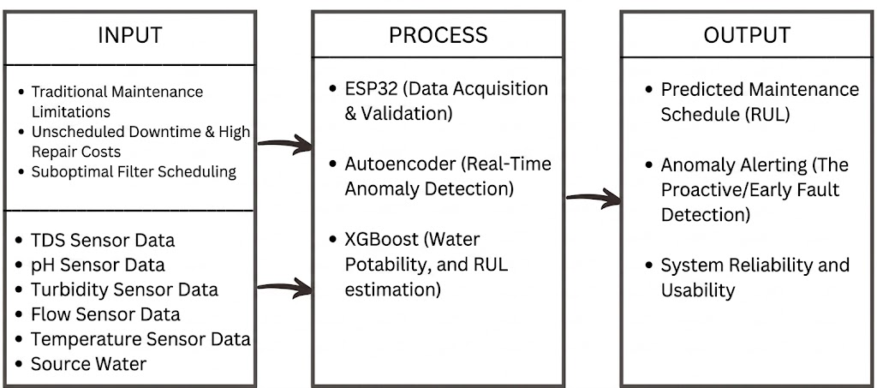
Figure 1. Input Process Output Diagram
According to Figure 1, the proposed system follows an Input–Process–Output (IPO) conceptual framework designed to improve water quality reliability, operational efficiency, and predictive maintenance in water refilling stations through IoT integration and machine learning. The framework begins with the input stage, which addresses existing operational challenges such as traditional maintenance limitations, unscheduled downtime, high repair costs, and suboptimal filter replacement scheduling. Alongside these identified problems, the system gathers real-time water quality and operational data from multiple sensors, including Total Dissolved Solids (TDS), pH, turbidity, flow rate, and temperature sensors, with source water serving as the primary monitored resource. These inputs provide the foundational data necessary for evaluating both water potability and filtration system condition.

In the process stage, the ESP32 functions as the primary data acquisition and validation device, continuously collecting, preprocessing, and transmitting sensor readings to the web-based platform for analysis. The collected data is then processed using integrated machine learning models. The Autoencoder model performs real-time anomaly detection by learning normal operational patterns and identifying unusual deviations through reconstruction error, enabling early fault detection and proactive maintenance alerts. Simultaneously, the XGBoost models serve dual purposes: one model evaluates water potability by classifying water quality conditions based on sensor inputs, while the second model estimates Remaining Useful Life (RUL) to predict filter degradation and optimize maintenance scheduling. This integrated process transforms raw sensor data into intelligent, data-driven maintenance insights.
The output stage generates actionable and measurable results that directly support operational decision-making. These outputs include Predicted Maintenance Scheduling through RUL estimation, Real-Time Anomaly Alerting for proactive fault detection, and improved System Reliability and Usability. By combining IoT-based monitoring, anomaly detection, and dual-purpose XGBoost predictive modeling, the system provides a sustainable and intelligent solution for managing water filtration systems. Ultimately, the framework aims to reduce downtime, minimize maintenance costs, optimize filter lifespan, and ensure the continuous delivery of safe, potable drinking water to the community.

Methodology
Research Design
This study employs an experimental research design to create and rigorously test an IoT-based Predictive Maintenance System for Water Filtration Systems using an integrated AI approach. The experiment is structured to validate the system's ability to transition maintenance from reactive/scheduled methods to predictive, data-driven scheduling. The physical system comprises IoT sensors, including flow rate, pH, turbidity, TDS, and temperature, all linked to an ESP32 microcontroller for real-time monitoring and data collection. The system focuses on monitoring key filtration components, particularly the Sediment Filter and Reverse Osmosis (RO) membrane, to assess both water quality and equipment condition. Real-time sensor data—including TDS, pH, turbidity, flow rate, and temperature—will be collected and validated through the ESP32 microcontroller, which serves as the primary data acquisition device before transmitting the information to the web-based platform for storage, processing, and analysis. The study utilizes three distinct machine learning models: two XGBoost models and one Autoencoder model. The first XGBoost model is designed for water potability classification, determining whether water quality parameters meet safe drinking standards, while the second XGBoost model is used for Remaining Useful Life estimation to predict filter degradation and optimize maintenance scheduling. The Autoencoder model is implemented for real-time anomaly detection, identifying significant deviations from normal operational patterns through reconstruction error thresholds to provide immediate fault alerts. To ensure system reliability, accuracy, and predictive precision, the collected data will undergo multiple preprocessing procedures, including sensor calibration, data cleaning, normalization, and feature engineering. The system’s effectiveness and validity will be evaluated through limited field trials in the selected water refilling station. Overall, this research aims to demonstrate an intelligent, sustainable, and web-integrated predictive maintenance approach through the effective combination of IoT technology, dual-purpose XGBoost models, and Autoencoder-based anomaly detection.
Methodological Framework
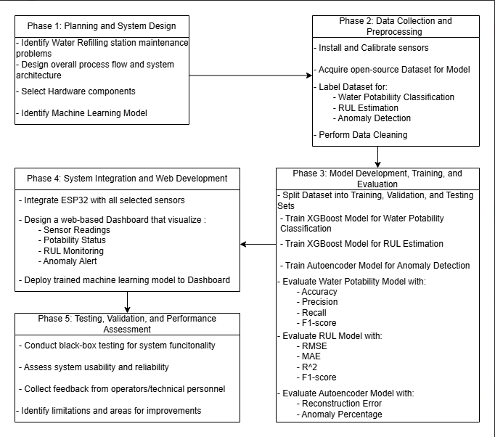
Figure 2. Methodological Framework of the Study
Phase 1: Planning and System Design
In this phase, the study identifies the key maintenance problems encountered in water refilling stations, including downtime, high repair costs, and inefficient filter scheduling.
The overall process flow and system architecture are designed, outlining how data moves from sensors to the predictive models and dashboard interface.
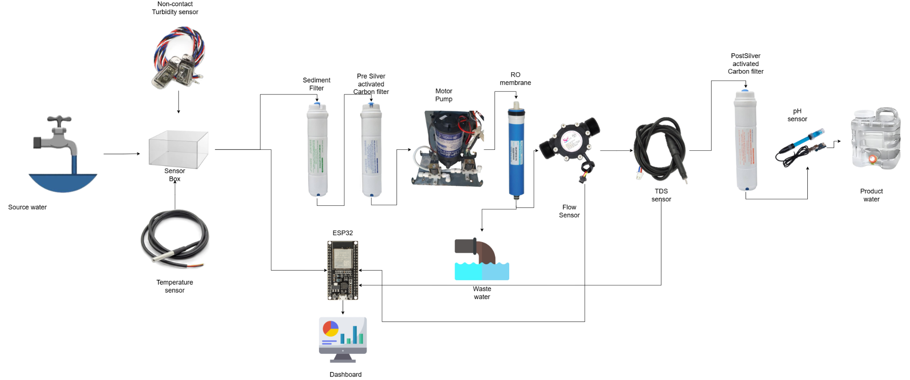
Figure 3. System Overview
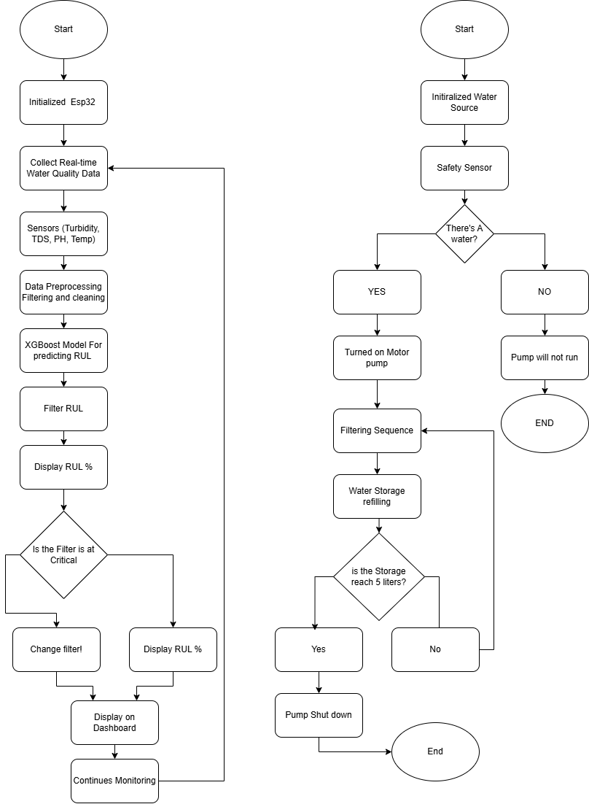
Figure 4. Predictive Maintenance and Water Filtration System Logic
Appropriate hardware components such as microcontrollers and sensors are selected based on system requirements. Additionally, the database structure and web dashboard interface are designed to ensure efficient data storage and visualization.
Table 1. Cost Analysis
QUANTITY | COMPONENTS | PRICE (₱) | COST (₱)
1 | Type C ESP32 Development Board 30 pins 38 pins | 349.00 | 349.00
1 | Waterproof Temperature Sensor DS18B20 | 99.00 | 99.00
1 | Water Flow Sensor Meter - Plastic 1/2" | Model: YF-S201 | 250.00 | 250.00
1 | DFRobot UART Non-contact Optical Turbidity Sensor for Arduino | SEN0554 | 690.00 | 690.00
1 | DFRobot Gravity: Analog pH Sensor / Meter Kit For Arduino® | SEN0161 | 1890.00 | 1890.00
1 | DFRobot Analog TDS Sensor/Meter | SEN0244 | 875.00 | 875.00
1 | 10L Portable Multifunctional Transparent water storage | 544.00 | 544.00
1 | Water Filter RO Booster Pump 2600NH for Increase Reverse Osmosis System Pressure | 2,094.00 | 2,094.00
1 | Sediment Filter | 1,600 | 1,600
1 | Pre-silver activated Carbon Filter | 1,600 | 1,600
1 | RO Membrane | 4,500 | 4,500
1 | Post-silver activated Carbon Filter | 1,600 | 1,600
1 | 100M/roll 1/4'' 6.35mm white PE tube PVC hose | 1,999.00 | 1,999.00
TOTAL |  |  | 18,090
The roles of machine learning models are identified, including classification for water potability, regression for remaining useful life (RUL), and anomaly detection.
Table 2. Model Identification
Model | Function | Reason
XGBoost | Water Potability | High accuracy for structured tabular water-quality data
XGBoost | RUL Estimation | Capable of regression on engineered degradation features without requiring sequential time-series data
Autoencoder | Anomaly Detection | Learns normal operational patterns without labels

Table 3. Structured KPI Table
Group | KPI Metric | Objective
Hardware Constraints | Power Consumption | Minimize ESP32 and pump energy usage.
Performance & Reliability | Prediction Accuracy | Maintain RMSE within acceptable benchmark ranges.
Project & Cost | System ROI | Reduce filter waste costs by at least 20%.
Software & Quality | Latency | Real-time dashboard updates < 5 seconds.
Phase 2: Data Collection and Preprocessing
In this phase, sensors are installed and calibrated to ensure accurate data acquisition. Real-time sensor data from the filtration system are collected, along with external or open-source datasets to support model training. Publicly available datasets were collected and reviewed to establish baseline parameter relationships, validate sensor variable selection, and support preliminary machine learning experimentation before real-world data acquisition.
Table 4. Dataset Identification
Dataset source | Dataset name | Purpose | Key Parameters
Kaggle | Water Potability Detection Dataset | To establish baseline water quality parameter relationships and validate the XGBoost classification model for water potability detection prior to real-world data acquisition. | pH, Solids, Turbidity, Potability
Kaggle | Water Quality Metrics & Filter Performance Dataset | To support RUL estimation and anomaly detection model development by validating sensor variable selection and enabling preliminary ML experimentation on filter degradation patterns. | TDS, Turbidity, pH, Flow Discharge, Filter Lifespan
The collected data are validated to ensure consistency and reliability. Data preprocessing techniques such as cleaning and normalization are applied to improve data quality.
Phase 3: Model Development, Training, and Evaluation
In this phase, machine learning models are developed to address the system objectives.
A classification model is implemented for water potability prediction, while a regression model is developed for estimating the remaining useful life of system components. An anomaly detection model is also created for real-time fault detection. The dataset is divided into training, validation, and testing sets to ensure unbiased evaluation. Model training and hyperparameter optimization are conducted to improve predictive performance. The models are evaluated using appropriate metrics. Classification performance is measured using accuracy, precision, recall, and F1-score, while regression performance is assessed using RMSE, MAE, and R². The anomaly detection model is evaluated based on reconstruction error and anomaly percentage. Based on these results, the models are refined and optimized.
Table 5. Model Training Result
Model | Metric | Result
XGBoost for Water Potability | Accuracy  Precision  Recall  F1-score | 0.80  0.73  0.77  0.75
XGBoost for RUL Estimation | RMSE (hours)  MAE (hours)  R² | 74.71  91.45  0.98
Autoencoder for Anomaly Detection | ROC-AUC  PR-AUC  Macro F1-score | 0.9274  0.9949  0.7056

Table 6. XGBoost RUL Decision Table

Health State | RUL Output (Hours) | Action Required
Normal | > 300 Hours | System operating within optimal parameters.
Early Degradation | 100 - 300 Hours | Monitor dashboard for increasing turbidity/ pressure.
Replace Soon | 24 - 100 Hours | Order replacement filter/ parts.
Critical | < 24 Hours | Maintenance required immediately to prevent downtime.

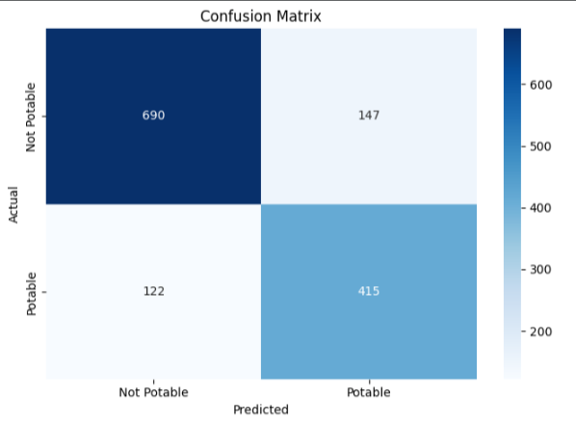
Figure 5. Confusion Matrix of Water Potability Model
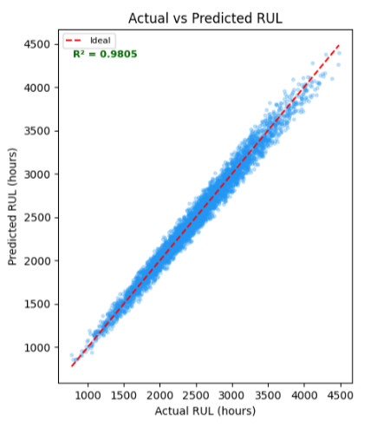
Figure 6. Scatter Plot of Actual vs. Predicted RUL Model
Phase 4: System Integration and Web Deployment
In this phase, the hardware and software components are integrated into a unified system. The microcontroller is connected with the selected sensors to enable real-time data acquisition.
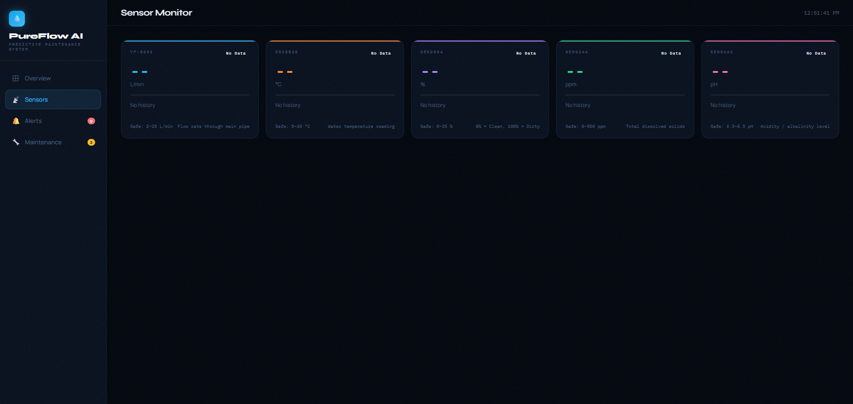
Figure 7. PureFlow AI Dashboard - Sensor Monitor
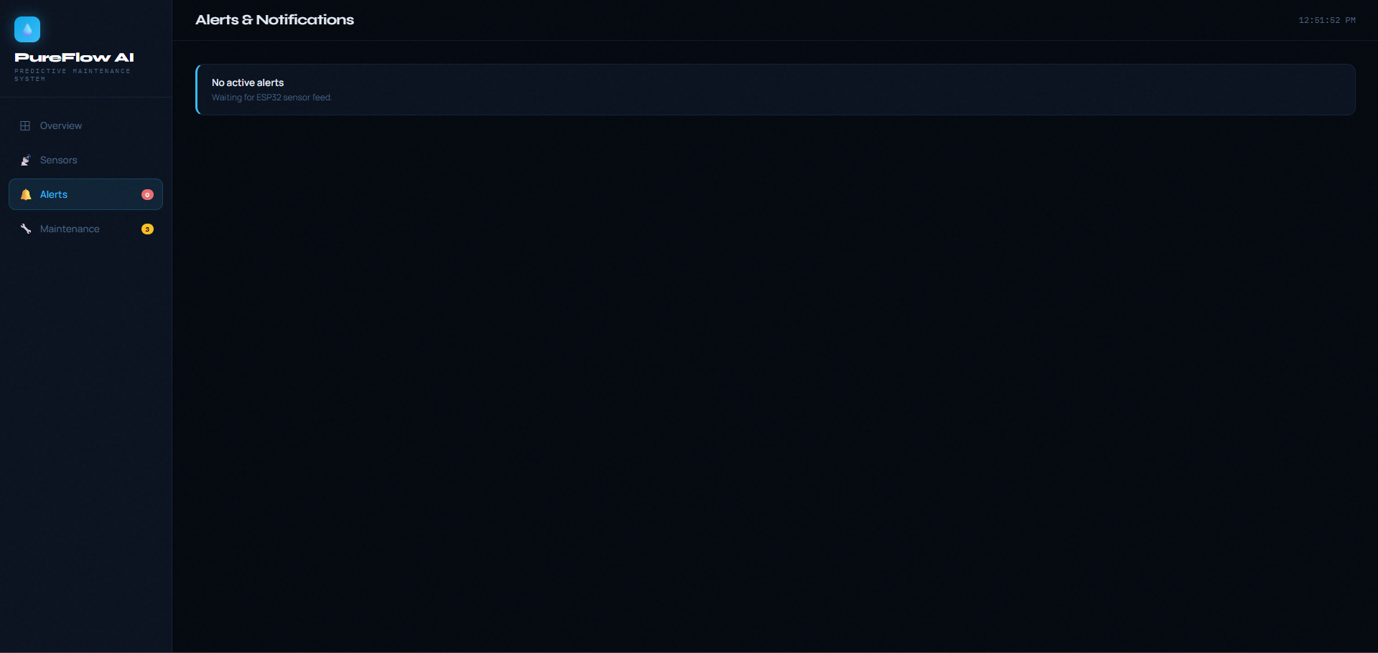
Figure 8. PureFlow AI Dashboard - Alerts & Notifications
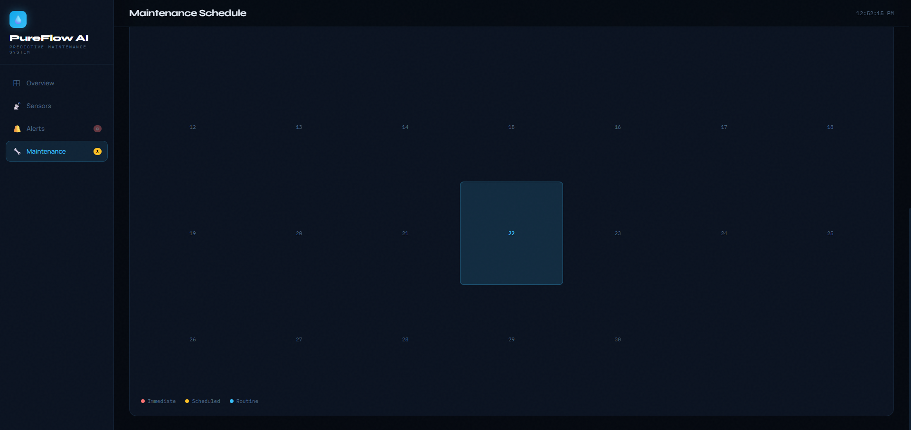
Figure 9. PureFlow AI Dashboard - Maintenance Schedule
The trained machine learning models are deployed to a web-based platform, where predictive outputs are integrated into a dashboard for visualization. The system implements key features such as sensor readings display, water potability status, RUL monitoring, and anomaly alerts. Finally, functional integration testing is conducted to ensure that the hardware, software, and AI components operate seamlessly as a complete system.
Table 7. Predictive Maintenance Decision Flow Table
Anomaly Type | Sensor Trigger | System Response/ Action
Turbidity Spike | Turbidity > Threshold | Alert: Check pre-filter; possible high raw water sediment.
Pressure Drop | Pressure < Baseline | Schedule Maintenance: Inspect pump and RO membrane for clogging.
TDS Rise | TDS > 500 ppm | Immediate Action: Replace RO membrane and ensure potability.
Flow Rate Decline | Flow < Minimum L/ min | Inspection: Check for pipe blockages or pump wear.

The table maps out specific system anomalies, the sensor readings that trigger them, and the corresponding actions required It serves as a troubleshooting or automated response guide for a water filtration or purification system.
Phase 5: Testing, Validation, and Performance Assessment
In the final phase, the system undergoes comprehensive testing and validation. Black-box testing is conducted to evaluate overall system functionality. Sensor accuracy and system response time are measured to ensure reliability. Feedback from operators and technical personnel is collected to evaluate system usability and effectiveness. The system’s limitations and areas for improvement are identified, and final validation is performed based on predictive maintenance key performance indicators (KPIs). Two Implementation KPIs are formally incorporated in this phase. System Downtime refers to the total non-operational duration of the system or station due to equipment failure or unplanned maintenance, measured in minutes or hours per observation period; a lower value indicates that predictive alerts are successfully preventing full equipment failure. Flowtime Efficiency refers to the percentage of total elapsed time during which the system operates within all acceptable sensor thresholds (TDS, turbidity, pH), calculated as: Flowtime Efficiency (%) = (Productive Operational Time / Total Elapsed Time) × 100. Both metrics are logged and tallied throughout the testing phase and shall serve as primary success indicators should full implementation proceed.
Subject of the Study
The subjects of this study are divided into two crucial groups necessary for the development and validation of PureFlow AI: an IoT-based Predictive Maintenance System for Water Filtration Systems in Water Refilling Stations using XGBoost and Autoencoder Algorithms.
The first is a miniature water filtration system prototype constructed and controlled by the researchers. This prototype replicates the core components of a real-world water refilling station, including sediment filtration, carbon filtration, and a reverse osmosis membrane. IoT sensors measuring turbidity, TDS, pH, temperature, and flow rate will be installed on the prototype to collect real-time operational data. This controlled setup allows the researchers to simulate normal operations, and gradual component degradation in a repeatable and measurable environment, ensuring reliable data collection for model training and validation.
The second group includes Human Respondents who will evaluate the system's usability and practical effectiveness. These respondents will be technical personnel such as water refilling station operators and maintenance staff from stations in or near Muntinlupa City. Rather than deploying the system directly at their stations, these individuals will be presented with the system's interface, predictive outputs, and alert features for evaluation. Their feedback will assess the system's usability, clarity of maintenance alerts, and practical relevance to real-world refilling station operations.
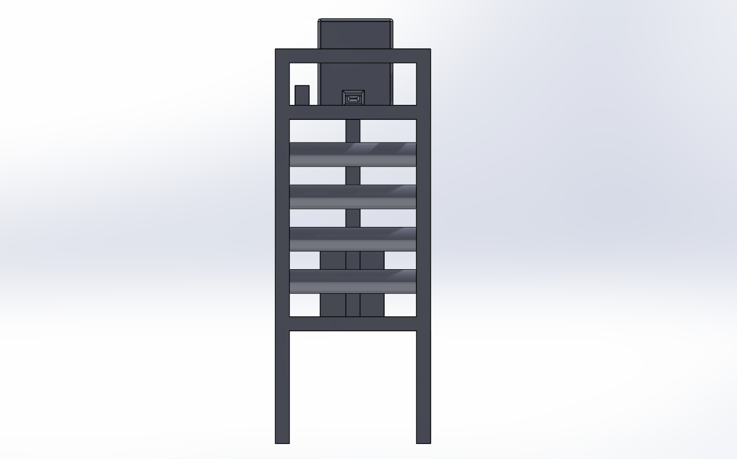
Figure 10. Front view of PureFlow AI 3D Model
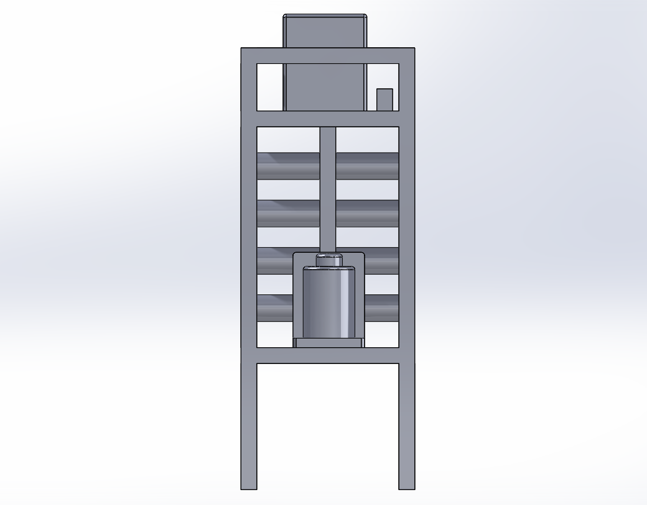
Figure 11. Rear view of PureFlow AI 3D Model
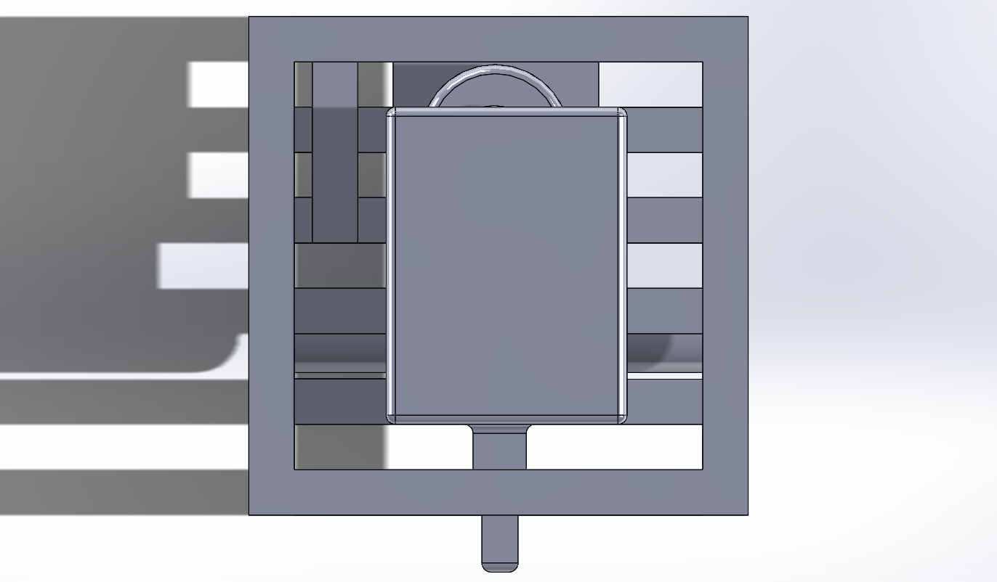
Figure 12. Top view of PureFlow AI 3D Model
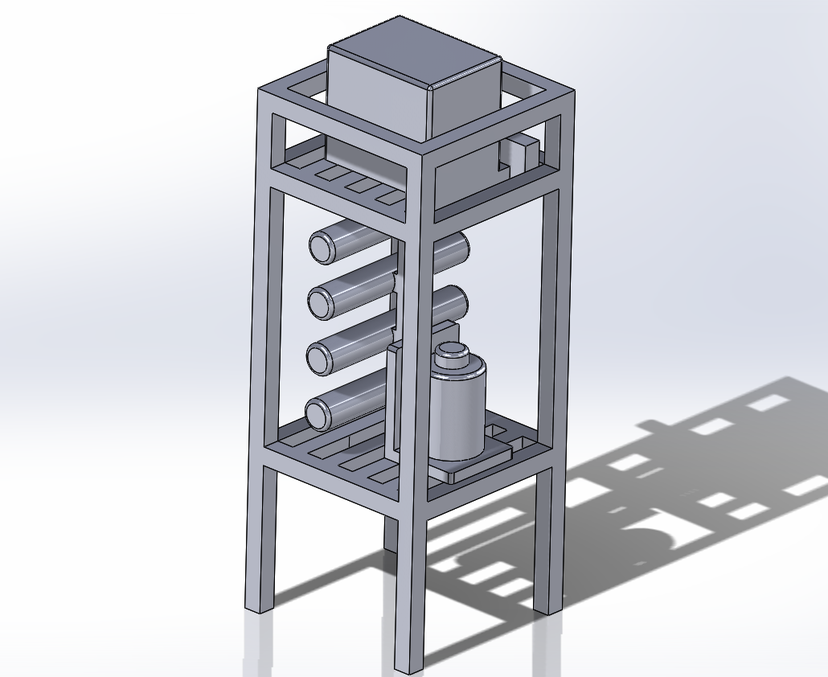
Figure 13. Side view of PureFlow AI 3D Model
Table 8. Physical System
Subject | Description | Purpose
Miniature Water Filtration Prototype | A researcher-constructed prototype replicating core filtration stages (sediment, carbon, RO membrane) installed with IoT sensors. | Primary subject of experimentation for real-time data collection, model training, and system validation.
IoT Sensors | Turbidity, TDS, pH, temperature, flow rate, and pressure sensors installed on the prototype. | To collect real-time operational data simulating normal operation, degradation, and fault conditions.

Table 9. Respondent Profiles
Respondent Group | Inclusion Criteria | Exclusion Criteria | Survey Focus
Technical Personnel (Station Managers / Operators) | Must be directly responsible for maintaining water refilling equipment or checking water quality at a water refilling station in or near Muntinlupa City. | Personnel whose primary role is customer service or administration and have no direct role in maintenance or water quality monitoring. | To evaluate the usability, clarity of predictive alerts, and practical relevance of the system's dashboard and maintenance scheduling outputs based on their operational experience.

Study Site
This study will be conducted at a specific water refilling station in Muntinlupa City, where filtration and purification systems are required for day-to-day operations in order to supply the community with safe drinking water. Given that it is a typical setup that encounters typical operational challenges like filter degradation, inconsistent water quality, and unplanned maintenance, this station was selected as the research location.
The chosen station is appropriate for testing the Internet of Things-based Predictive Maintenance System because it has several filtration stages, such as sediment, carbon, and reverse osmosis filters. Turbidity, TDS, pH, temperature, and flow sensors are among the Internet of Things sensors that will be installed at this location. The sensors will be linked to an ESP32 microcontroller for data processing and collection.
By conducting the study in this practical location, researchers will be able to collect data in real-time and verify how well the predictive models (XGBoost and Autoencoder) perform in actual operational areas. The system's practical applicability, scalability, and potential to enhance water quality, operational reliability, and maintenance efficiency in comparable refilling stations throughout the city are all guaranteed by the location selection.

Data Measures
The data measures to be used in this study focus on evaluating the predictive maintenance performance of the IoT-based monitoring system specifically integrated into the Reverse Osmosis (RO) filtration process of water refilling stations. The system will continuously collect real-time operational and water quality parameters such as flow rate (L/min), Total Dissolved Solids (TDS, ppm), Turbidity (NTU), pH, conductivity, residual chlorine, and water temperature (°C), using IoT-enabled sensors strategically positioned along the filtration line. These raw measurements will serve as the primary inputs for the XGBoost water potability classification model, Remaining Useful Life (RUL) prediction model, and the Autoencoder anomaly detection model. To validate water quality, the collected sensor readings will be benchmarked against the Philippine National Standards for Drinking Water (PNSDW) under Department of Health Administrative Order No. 2017-0010, particularly for parameters such as pH, turbidity, Total Dissolved Solids (TDS), and residual chlorine. Water samples will be classified as potable or non-potable depending on whether the measured values remain within the allowable drinking-water standards established by the Department of Health (DOH, 2017). This standards-based validation framework ensures that the predictive maintenance system not only detects equipment degradation and operational anomalies but also maintains compliance with recognized drinking water safety requirements.
For predictive maintenance, the XGBoost model will process sensor data to forecast the degradation of critical components and estimate their Remaining Useful Life (RUL). The predictive performance of the model will be quantitatively evaluated using regression metrics, including:
- Root Mean Squared Error (RMSE): Indicates the standard deviation of prediction errors, providing a measure of prediction consistency and overall accuracy.
- Mean Absolute Error (MAE): Represents the average magnitude of prediction errors in actual measurement units, allowing easier interpretation for maintenance scheduling.
- Coefficient of Determination (R²): Assesses how much of the variability in equipment degradation is explained by the model, reflecting overall reliability.
- F1-Score: Represents the harmonic mean of precision and recall, providing a balanced measure of the model's classification performance in identifying degradation states accurately.
For water potability classification using XGBoost, performance metrics such as accuracy, precision, recall, and F1-score may be computed to validate water quality output.
The Autoencoder model will use reconstruction error metrics to detect real-time anomalies in system behavior.
The developed predictive maintenance system validates water potability using operational sensor measurements benchmarked against the Philippine National Standards for Drinking Water (PNSDW) under Department of Health Administrative Order No. 2017-0010. The system classifies water as potable or non-potable depending on whether the measured parameters remain within the allowable drinking-water standards established by the Department of Health (DOH).
Table 10. Water Quality Validation Parameters Based on PNSDW 2017
Parameter | Range / Limit | System Interpretation
pH | 5.0 – 7.0 | Outside range indicates abnormal acidity or alkalinity
Total Dissolved Solids | ≤ 10 mg/L | High TDS may indicate RO membrane degradation or contamination
Tubidity | ≤ 5 NTU | High turbidity suggests inadequate filtration
Temperature | 20°C – 35°C | Abnormal temperature may indicate pump stress or overheating
Although classification and anomaly detection are included, the primary analytical focus of the study remains the regression-based prediction of RUL for proactive maintenance planning.
Data Collection Procedure
1. Interviews and Preliminary Research
The study will begin with interviews and preliminary assessments conducted with selected water refilling station owners and operators within Muntinlupa City. These interviews will identify common issues such as RO pump overheating, membrane fouling, and unplanned downtime. The information gathered will guide the selection of data parameters, sensor placements, and overall development of the predictive maintenance framework.
2. Laboratory Setup and Calibration
Following the preliminary research, the prototype system will be assembled and tested in a controlled laboratory environment. The setup will include an ESP32 microcontroller connected to a flow sensor, a TDS sensor, a turbidity sensor, a pH sensor, and a temperature probe. Each device will undergo calibration to ensure accuracy, beginning with baseline measurement collection to establish normal operational thresholds. These baseline parameters will be used as reference points for detecting deviations associated with membrane fouling, pump stress, or abnormal system conditions.
3. Field Deployment and Data Gathering
After calibration, the system will be tested at our miniature water refilling station set-up. The system will continuously gather real-time operational data—such as TDS concentrations, flow rates, pH levels, turbidity levels, and temperature—and transmit them to a web-based dashboard platform via the ESP32 over wifi connection. Data collection will span several weeks to capture daily operational variations, gradual degradation patterns, and sudden anomalies for model training and validation.
4. System Testing and Performance Assessment
The final stage will involve pilot testing of the predictive maintenance system. The researchers will monitor the accuracy and responsiveness of the XGBoost water potability and RUL estimations, and the Autoencoder anomaly detection module. Station operators will be consulted to provide feedback regarding the practicality, real-time effectiveness, and usability of the system’s alerting and dashboard features. The collected data and user feedback will be compiled and analyzed to evaluate system performance and identify areas for improvement in both hardware and algorithm design.
Ethical Considerations
The researchers will ensure that all procedures respect participant rights, maintain data confidentiality, and comply with institutional ethical standards. Since the study will involve the participation of water refilling station owners and the collection of real-time operational data, strict adherence to ethical guidelines will be observed throughout all phases of the research.
- Permission and Approval. Before any testing or installation takes place, formal permission will be obtained from the participating water refilling stations. Each station owner will sign a letter of cooperation that will outline the objectives, duration, and scope of the study.
- Informed Consent. Informed consent will be obtained from all participating station owners and operators prior to the start of the study. Each participant will be provided with a consent form that will explain the study’s purpose, the nature of the data to be collected, and the expected duration of their participation. The consent form will also emphasize voluntary participation, confidentiality, and the participants’ right to withdraw from the study at any time without penalty.
- Data Privacy and Confidentiality. All collected data will be treated with strict confidentiality. No personal or customer information will be gathered during the study. Sensor readings, and performance data will be securely stored in an encrypted cloud database accessible only to the researchers. The collected information will be used solely for research, development, and academic reporting and will be presented in aggregate form to prevent the identification of specific participants or locations.
- Transparency and Responsible Data Use. Transparency will be maintained by keeping all participants informed about the research process, objectives, and outcomes. The researchers will commit to using all gathered data solely for academic and developmental purposes related to predictive maintenance. After the study, each participating station will be provided with a summary of findings, including insights into their system performance and recommendations for improving maintenance efficiency. These measures will ensure that the study is conducted with fairness, accountability, and respect for all involved.
Data Analysis
1. Data Preprocessing
- Sensor readings such as low rate (L/min), Total Dissolved Solids (TDS, ppm), Turbidity (NTU), pH levels, and water temperature (°C) will be collected through the ESP32 microcontroller.
- Raw data will undergo cleaning procedures to remove sensor noise, electrical fluctuations, missing values, and abnormal spikes caused by environmental disturbances.

2. Data Segmentation
- The processed dataset will be divided into training, validation, and testing sets.
- Approximately 70% of the data will be used for training, 15% for validation, and 15% for final testing to ensure robust model generalization.
- A classification model is implemented for water potability prediction, while a regression model is developed for estimating the remaining useful life of system components. An anomaly detection model is also created for real-time fault detection.

3. Feature Analysis and Correlation
- Statistical summaries such as mean, variance, standard deviation, and correlation between operational parameters (pH, turbidity, flow, TDS, and temperature) will be computed.
- Correlation analysis will identify key indicators of RO membrane fouling, pump overheating, pressure drops, or flow restrictions.
- Visualization tools will be used to examine dependencies between degradation factors and equipment behavior, supporting feature selection for model training.

4. Model Training and Prediction
- The first XGBoost model will be used to forecast water potability.
- The second XGBoost model will be used to estimate the Remaining Useful Life (RUL) of the RO membrane, and classify operational states such as normal operation, early degradation, membrane clogging based on historical label patterns.
- The Autoencoder model will be trained to learn a baseline of normal multivariate system behavior and will detect anomalies by analyzing reconstruction errors in real time.

5. Performance Evaluation
- Model outputs will be compared with actual sensor data and observed component conditions using the following metrics:
  - Mean Squared Error (MSE)
  - Root Mean Squared Error (RMSE)
  - Mean Absolute Error (MAE)
  - Coefficient of Determination (R²)
To ensure that these performance indicators yield an operationally actionable interpretation, this study incorporates a structured validation framework based on relevant predictive maintenance benchmarks.

Core Validation Approach
The XGBoost RUL prediction model will be rigorously evaluated using standard prognostic performance metrics and validation methods established in predictive maintenance literature (specifically referencing Liu et al., 2025). The evaluation relies on two main pillars:
- Performance Metrics: The model will track Root Mean Square Error (RMSE) and Mean Absolute Error (MAE). RMSE serves as the primary benchmark to quantify the deviation between the predicted filter lifespan and the actual remaining life of the Reverse Osmosis (RO) system.
- Robustness Testing: Cross-validation and testing on independent datasets will be used to ensure the model remains reliable across diverse operating conditions.

Performance Benchmarks
To determine if the model is practical for real-world maintenance scheduling, its prediction error (RMSE) is categorized into three performance tiers based on the total expected filter lifespan:
- Excellent Prediction: RMSE < 10% of actual lifespan (e.g., an error under 10 days for a 100-day filter).
- Acceptable Prediction: RMSE between 10%-20% of actual lifespan (e.g., an error of 10 to 20 days).
- Poor Prediction: RMSE > 20% of actual lifespan (e.g., an error exceeding 20 days; deemed insufficient for reliable scheduling).
- For XGBoost classification, metrics such as accuracy, precision, recall, and F1-score may be computed to validate operational state prediction.
- For Autoencoder anomaly detection, threshold-based reconstruction error metrics will be used to determine anomaly sensitivity.
The anomaly threshold is defined using the Autoencoder's Reconstruction Error (RE). Instead of an arbitrary value, the threshold is derived via a Precision-Recall curve to maximize the Macro F1-score, ensuring balanced detection accuracy. To prevent false alarms, this limit enforces at least a 70% recall rate for normal operations. Any real-time sensor reading that exceeds this optimized threshold is flagged as an anomaly, triggering the predictive maintenance alert.
- These evaluation criteria will determine how accurately the system identifies developing faults, predicts RUL, and detects abnormal behavior.

6. Visualization and Interpretation
- Visualization tools such as Matplotlib will be used to plot sensor trends, degradation curves, anomaly scores, and predicted vs. actual values.
- Time-series graphs will illustrate filter deterioration, temperature, TDS, Turbidity, pH, and flow rate changes and decay patterns over time.
- The predictive performance of the system will be interpreted to assess its ability to recommend timely maintenance, reduce downtime, and improve decision-making accuracy for station operators.

Tentative Gantt Chart
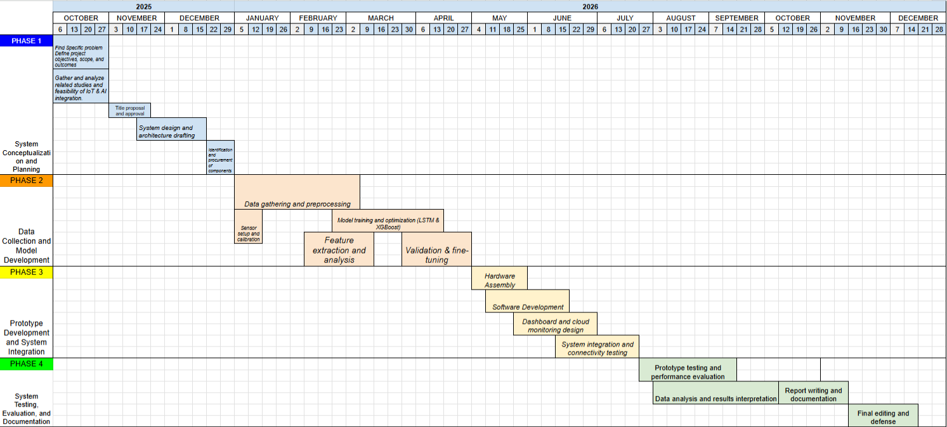
Figure 14. Tentative Gantt Chart

REFERENCES
Abrajano, J. V., Botangen, K. A., Nabua, J., Apanay, J., & Peña, C. F. (2024). IoT-Based
Water Quality Monitoring System in Philippine Off-Grid Communities.

Ahmed, A. (2025). Hybrid and deep learning architectures for predictive maintenance:
Evaluating LSTM, and attention-based LSTM-XGBoost on turbofan engine RUL. MATEC Web of Conferences, 413, 07008. https://doi.org/10.1051/matecconf/2025413 07008

Ambure, R. D., & Kulkarni, S. M. (2025, April 28). Smart Water Tap and Purifier System
using IOT: A Step Towards Sustainable Water Conservation. International Journal of Engineering Research & Technology. https://www.ijert.org/smart-water-tap-and-purifi er-system-using-iot-a-step-towards-sustainable-water-conservation

Anitha, K., Vijayakumar, R., Gnana Jeslin, J., Elangovan, K., Jagadeeswaran, M., &
Srinivasan, C. (2024). Marine Propulsion Health Monitoring: Integrating Neural Networks and IoT Sensor Fusion in Predictive Maintenance. 2024 2nd International Conference on Device Intelligence, Computing and Communication Technologies (DICCT), 1-6. 10.1109/DICCT61038.2024.10533037
Ansari, S. A., & Vidyarthi, V. K. (2025). Use of internet of things in Water Resources Applications: Challenges and Future Directions: A critical review. Discover Internet of Things, 5(1). https://doi.org/10.1007/s43926-025-00193-7
Baranwal, T., et al. (2025). Machine Learning-Based Anomaly Detection of Correlated
Sensor Data: An Integrated Principal Component Analysis-Autoencoder Approach.

Barnard, J., & Stryker, C. (2025, November 17). Anomaly detection. What is anomaly detection? https://www.ibm.com/think/topics/anomaly-detection

Bergmann, D., & Stryker, C. (2025, November 17). Autoencoder. What is an autoencoder? https://www.ibm.com/think/topics/autoencoder

Catajan Jr, A., Fajardo, A., & Limbago, J. (2023, June 28). Classification of Water
Quality Index in Laguna de Bay using XGBoost. 2023 20th International Joint Conference on Computer Science and Software Engineering (JCSSE) (pp. 1–6). IEEE. https://doi.org/10.1109/JCSSE58229.2023.10202029

Cruz, Y. J., Castaño, F., & Haber, R. E. (2025). Long Short-Term Memory Mixture
Density Network for Remaining Useful life Prediction of IGBTs. Technologies, 13(8), 321. https://doi.org/10.3390/technologies13080321

Cummins, L., Sommers, A., Bakhtiari Ramezani, S., Mittal, S., Jabour, J., & Seale, M.
(2024). Explainable Predictive Maintenance: A Survey of Current Methods, Challenges and Opportunities. IEEE Access, 12, 57574 - 57602. 10.1109/ACCESS.20 24.3391130
Dada, M. A., Daraojimba, O. H., Majemite, M. T., Nwokediegwu, Z. Q. S., Obaigbena,
A., & Oliha, J. S. (2024). Review of smart water management: IoT and AI in water and wastewater treatment. World Journal of Advanced Research and Reviews, 21(01), 1373–1382. https://doi.org/10.30574/wjarr.2024.21.1.0171

Davari, S., Veloso, B., Costa, P., Pereira, P., & Gama, J. (2021). A survey on data-driven
predictive maintenance for the railway industry. Sensors, 21(17), 5739. https://doi.org /10.3390/s21175739

de Luna, R. G., Magnaye, V. C., Reaño, R. A. L., Enriquez, K. L., Dalguntas, J. M. R.,
Lizardo, A. J. M., Molino, E. S. A., Pucyutan, A. A. L., Solis, J. C., & Umali, D. Y. D. (2023, October 31). A Comparative Study of Machine Learning Techniques for Water Potability Classification. TENCON 2023 - 2023 IEEE Region 10 Conference (TENCON). https://doi.org/10.1109/TENCON58879.2023.10322335

Demetillo, A. T., et al. (2019). Cost-Effective Water Quality Monitoring System Using
IoT. International Journal of Advanced Trends in Computer Science and Engineering.

FLOWATER. (2024, July 24). Reducing Plastic Waste at Events: The Role of Water Refill
Stations. https://drinkflowater.com/reducing-plastic-waste-at-events-the-role-of-w
ater -refill-stations/

Goal 6: Clean water and sanitation - The Global Goals. (2024, January 23). The Global
Goals. https://globalgoals.org/goals/6-clean-water-and-sanitation/

Goal 9: Industry, innovation and infrastructure - The Global Goals. (2024, January 23).
The Global Goals. https://globalgoals.org/goals/9-industry-innovation-and-infrastr ucture/

Goncalves, Tanya. (2022, July 14). Predictive maintenance (PdM). Fiix. https://fiixsoftwa
re.com/maintenance-strategies/predictive-maintenance/

Goncalves, Tanya. (2024, April 26). Remaining useful life (RUL). Fiix. http://fiixsoftware
.com/maintenance-metrics/remaining-useful-life/

Guezouli, L. (2024). IoT and AI for Real-time Water Monitoring and Leak Detection.
Journal of Renewable Energies.

Hassan, A., Chen, J., & Zhang, T. (2023). IoT-enabled predictive maintenance: Review
and challenges. IEEE Access, 11, 40954–40973. https://doi.org/10.1109/ACCESS.2023.3 274192

Hossain, N., Dayarathna, V. L., Nagahi, M., & Jaradat, R. (2021). Systems thinking: A
review and bibliometric analysis. Systems, 9(3), 23. https://doi.org/10.3390/system s9030023
Huang, X., Zhuang, X., Tian, F., Niu, Z., Chen, Y., Zhou, Q., & Yuan, C. (2025). A
Hybrid ARIMA-LSTM-XGBoost Model with Linear Regression Stacking for Transformer Oil Temperature Prediction. Energies, 18(6), 1432. https://doi.org/10. 3390/en1806143 2

Jern, M. (2021, July 24). Can I drink the tap water in the Philippines? Best water filter? Tapp Water. https://tappwater.co/blogs/blog/tap-water-philippines-water-filter

Kaç, S. B., & Eken S. (2024). Sensor Fault Detection and RUL Estimation for Drinking
Water Pumping Stations. IEEE Sensors Journal, 24(9), 15620 - 15629. 10.1109/JS EN .2024.3379738

Koli, A. B., Akil, B. F. S., Kantilal, L. B., Madhukar, P. D., & Sanjay, P. R. (2025). A hybrid approach to water quality classification using SVM and XGBoost method. International Journal of Research and Scientific Innovation, XII(VI), 1006–1009. https://doi.org/10.51244/ijrsi.2025.12060080

Koons, E. (2024, June 20). Water pollution in the Philippines. Energy Tracker Asia. https://energytracker.asia/water-pollution-in-the-philippines/
Kushwaha, S., & Pandey, R. (2025). Intelligent IOT-based water quality monitoring and predictive analysis using machine learning. AI Systems Engineering, 1(2), 8–16. https://doi.org/10.64229/dnq1tb95
Liu, H., Li, Y., & Zhao, J. (2023). Recent advances in machine learning for predictive
maintenance: A comprehensive review. Applied Sciences, 13(4), 2251. https://doi.o rg/10.3390/app13042251
Liu, Y., Wen, J., & Wang, G. (2025). A comprehensive overview of remaining useful life prediction: From traditional literature review to scientometric analysis. Machine Learning with Applications, 1, Article 100704. https://doi.org/10.1016/j.mlwa.2025.100704
Liu, Y. H., & Chung, Y. C. (2025). The Data Acquisition System on Vibration Evaluation
and Predictive Maintenance for Cooling Water Pumps System. National Synchrotron Radiation Research Center.

Naim, S. M., Das, P., Tiang, J., & Nahid, A. (2025). Aquaculture Water Quality
Classification Using XGBoost ClassifierModel Optimized by the Honey Badger Algorithm with SHAP and DiCE-Based Explanations. Water, 17(20), 2993. https://do i.org/10.3390/w17202993

Nanavaty, D. (2024). Predictive Maintenance in Geothermal Power Plants using
Autoencoders and XGBoost. Stanford Geothermal Workshop.

Pasika, S., & Gandla, S. T. (2020). Smart water quality monitoring system with cost-effective using IoT. Heliyon, 6(7), e04096.

Oxmaint. (2024, April 5). What is Unplanned Maintenance?. https://oxmaint.com/blog/po
st/what-is-unplanned-maintenance

Rahaman, M. (2022). A review on Internet of Things (IoT) architecture, technologies,
future applications & challenges. International Journal of Science and Business, 14(1), 1–10. https://doi.org/10.5281/zenodo.7447255

Rane, N. (2023). Framework for AI-Driven Predictive Maintenance in IoT-Enabled Water
Treatment Plants. International Journal of Scientific Research in Computer Science Engineering.

Rhachi, H., Balboul, Y., & Bouayad, A. (2025). Enhanced Anomaly Detection in IoT
Networks Using Deep Autoencoder. Sensors, 25(10), 3150.

Saddiqi, H. A., Javed, Z., Ali, Q. M., & Ullah, A. (2024). Optimization and predictive modeling of membrane-based produced water treatment using machine learning models. Chemical Engineering Research and Design, 207, 65–76. https://doi.org/10.1016/j.cherd.2024.05.019

Salim, K., Hebri, R. S. A., & Besma, S. (2022). Classification Predictive Maintenance
Using XGboost with Genetic Algorithm. Revue D Intelligence Artificielle, 36(6), 833–845. https://doi.org/10.18280/ria.360603

Samatas, C., Moumgiakmas, A., & Papakostas, N. (2021). Predictive
maintenance—Bridging artificial intelligence and IoT. Procedia Manufacturing, 54, 31–38. https://doi.org/10. 1016/j.promfg.2021.07.005

Sarker, M. A. R., Chowdhury, M. A. H., Haque, M. T., Rahman, M. M., Meftaul, I. M., & Jubayer, M. F. (2025). From data to decision: leveraging machine learning and water quality index for groundwater quality evaluation. Sustainable Water Resources Management, 11, 102. https://doi.org/10.1007/s40899-025-01276-7

Shafiee, M., & Sørensen, J. D. (2021). Maintenance optimization using machine learning
methods: A review. Journal of Quality in Maintenance Engineering, 27(2), 208–229. https://doi.org/10.1108/JQME-09-2019-0074

Sharma, J., Gill, K. S., Kumar, M., & Rawat, R. (2024, November 10). Innovating Water
Purity Analysis with Gradient Boosting Classification Techniques. https://www.public ations.scrs.in/chapter/978-81-955020-9-7/14

Shofiana, D. A., Caniadi, M., Sholehurrohman, R., & Aristoteles, N. (2025). Decision
Tree Algorithms in Water Quality Classification: A comparative study of random Forest, XGBOost, and C5.0. Science & Technology Indonesia, 10(4), 999–1011. https://doi.or g/10.26554/sti.2025.10.4.999-1011

Slany, V., Krcalova, E., Balej, J., Zach, M., Kucova, T., Prauzek, M., & Martinek, R.
(2025). Smart Water-IoT: Harnessing IoT and AI for Efficient Water Management. ACM Computing Surveys, 57(12), 1-36. https://doi.org/10.1145/3744338

The Role of Filtration in Ensuring Water Potability. (2025, July 19). LIVE TO PLANT. H
ttps: //livetoplant.com/the-role-of-filtration-in-ensuring-water-potability/#article

Toleva, B., Ivanov, I., & Kitova, K. (2023). Innovative Machine Learning Approaches for
Drinking Water Quality Classification: Addressing Data Imbalances with Custom SMOTE Sampling Strategy. Journal of Environmental & Earth Sciences.

Ucar, A., Karakose, M., & Kırımça, N. (2024). Artificial intelligence for Predictive
maintenance Applications: key components, trustworthiness, and future trends. Applied Sciences, 14(2), 898. https://doi.org/10.3390/app14020898

UpKeep. (2024, September 26). What is unplanned maintenance? https://onupkeep.com/blog/what-is-unplanned-maintenance/

Valentinov, V. (2022). System or process? A meta-theoretical reflection on the nature of
the firm. Systemic Practice and Action Research, 35(4), 509–519. https://doi.org/1 0.1007/ s11213-021-09555-y

Velasco-Loera, F., Alcaraz-Mejia, M., & Chavez-Hurtado, J. L. (2025). An interpretable
hybrid fault prediction framework using XGBoost and a probabilistic graphical model for predictive maintenance: A case study in textile manufacturing. Applied Sciences, 15(18), 10164. https://doi.org/10.3390/app151810164

Wang, Y., & Liu, Z. (2025). Accurate prediction of machines Remaining Useful Life
(RUL) using Attention-LSTM-XGBoost. MATEC Web of Conferences.

Water Quality Prediction using Classification techniques on XGBoost, KNeighbors, SVC,
Random Forest, AdaBoost, and GaussianNB Classifier. (n.d.). IEEE Conference Publication | IEEE Xplore. https://ieeexplore.ieee.org/document/10426257

What Happens When You Don’t Have a Maintenance Plan. (2025, July 16). FieldEx. http
s://www.fieldex.com/en/blog/what-happens-when-you-dont-have-a-maintenance-plan

Xiong, Z., Liu, X., Igou, T., Li, Z., & Chen, Y. (2025). Using hybrid machine learning to predict wastewater effluent quality and ensure treatment plant stability. Water, 17(13), 1851. https://doi.org/10.3390/w17131851

